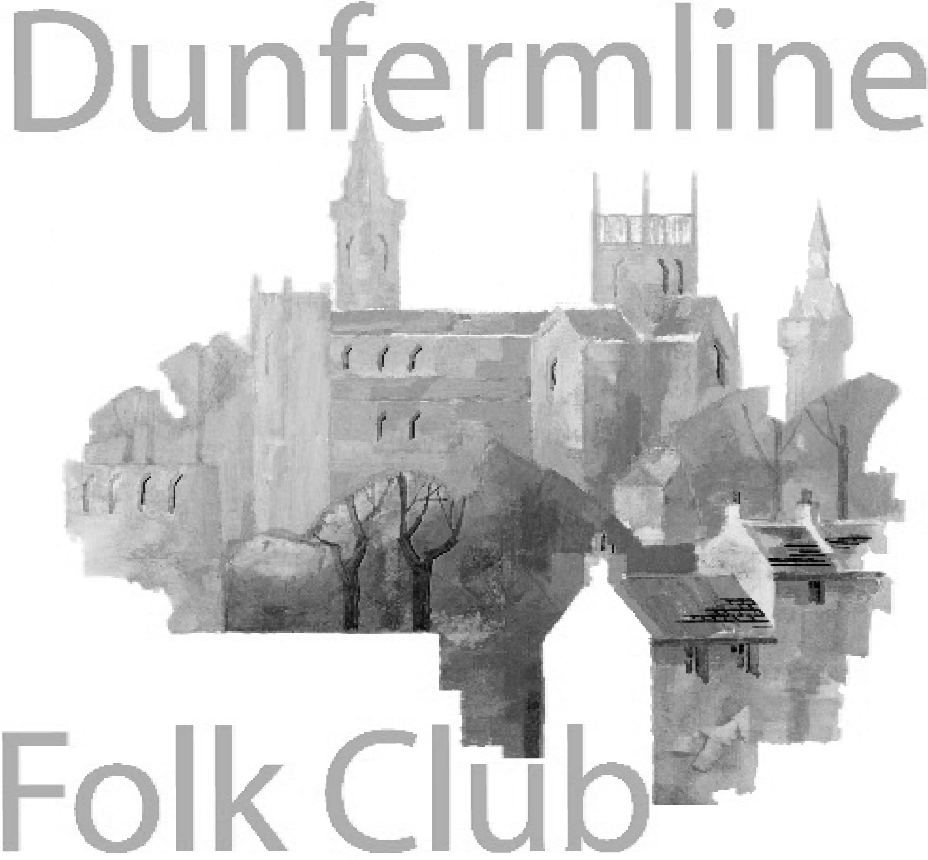
Dunfermline Folk Club Events
In The Glen Tavern, 110-112 Pittencrieff St, Dunfermline KY12 8AN

8.00pm start every Wednesday

June 2019
5 Chris Clevely " At times we see artists who have crafted a unique place for themselves within the genre. Chris Cleverley has emerged as a songwriter, performer and character who defies comparison. His innovative brand of 21st Century Alt-folk is characterised as much by his challenging songwriting as his blistering fingerstyle guitar technique. Described as ‘Impressive’ by The Telegraph, Chris is fast gaining the accolade of being among the most masterful, inventive and unique players on the scene. Continuing the legacy of heroes Nic Jones and John Martyn the essence of the folk revival abounds in his memorable songwriting and energetic traditional arrangements. See www.chriscleverley.com/ Club Performer: Bernie Hewitt : Entry £8 (£6 for members)​​​
12 Luckenbooth Luckenbooth are a three piece band from Lanarkshire and have been playing together for around 20 years. They play a mix of folk, country and pop on a variety of instruments including guitar, fiddle, keyboard and whistles. They love to get audiences to sing along. Club Singer: TBC​ Entry £8 (£6 for members)​​​
19 Odette Mitchell - folk singer songwriter based in Hertfordshire who accompanies herself on the guitar and bouzouki. See www.odettemitchell.com Club Singer: Gifford Lind. Entry £8 (£6 for members)​​​
26 Session. Sing a song, play a tune, tell us a story or listen and celebrate in style. Theme: Duets. Collection for the club..
July 2019
3 Ivan Drever Orcadian musician whose lyric song-writing, extensive traditional repertoire and virtuoso guitar playing have been part of the Scottish music scene for over 30 years. see www.ivandrever.co.uk. Club singer: Robin McLean. Entry £8 (£6 for members)​​​​
10 Peter and Barbara Snape The Snapes are two fine performers with a well-deserved national reputation for performing traditional British folk music. With carefully researched material from their native North West of England, they will leave you in good spirits. Their selection of traditional songs with melodeon accompaniment is infectious and compels you to listen and take part. see http://www.thesnapes.org.uk/ Club Singer: Ena Robertson. Entry £8 (£6 for members)​​
17 Ella Munro Ella Munro is a young folk singer from the Isle of Skye, currently based in Glasgow. In 2017 she became a BBC Radio Scotland Young Traditional Musician of the Year finalist and has toured Scotland and beyond successfully since, however, with a passion for some of the most well-loved Scottish folk songs, she has discovered that folk clubs are where she would most like to sing. With a much-awaited debut EP on the way and sell out performances behind her, she is sure to have everyone singing along! See her on youtube Club singer: Alex Black. Entry £8 (£6 for members)​​​
24 Tom Lewis. "It's not all about sea-shanties.... my stage presentation encompasses the tradition, my own songs (some of which I'd wager you'll have heard), songs stolen from other writers; all knitted together with engaging and informative chat. With enough choruses to keep audiences involved, about half of the show is unaccompanied; whilst the rest of the songs are underpinned with a bit of melodeon or ukulele accompaniment." Club singer: Jim Wardell. Entry £8 (£6 for members)​​
31 Session. Sing a song, play a tune, tell us a story or listen and celebrate in style.Theme: colours. Collection for the club.

August 2019
7 Brack'n'File Guitarist Tony Mitchell, Shetland based bassist Rick Nickerson and singer Maureen Brack - The group performs traditional and contemporary songs and instrumentals. See https://www.facebook.com/BracknFile/ Entry £8 (£6 for members)​
14 Claude Bourbon - medieval & Spanish blues ​ www.claudebourbon.org/​ Entry £8 (£6 for members)​
21 Ewan Macintyre Band . Puppeteer, musician and ex-lead singer songwriter of the award-winning Edinburgh collective Southern Tenant Folk Union. Ewan Macintyre has a rare ability to pen songs in a range of styles. Together with his band from Canada and Scotland, Ewan Macintyre weaves his own blend of folk pop traditions. see http://www.ewan-macintyre.org Entry £8 (£6 for members)​28 Session. Sing a song, play a tune, tell us a story or listen and celebrate in style. Collection for the club.

Please note that the programme may change due to circumstances outwith our control - especially for events several months in the future. Please check again before coming to the club.

For further information visit www.dunfermlinefolkclub.co.uk or our Facebook page

