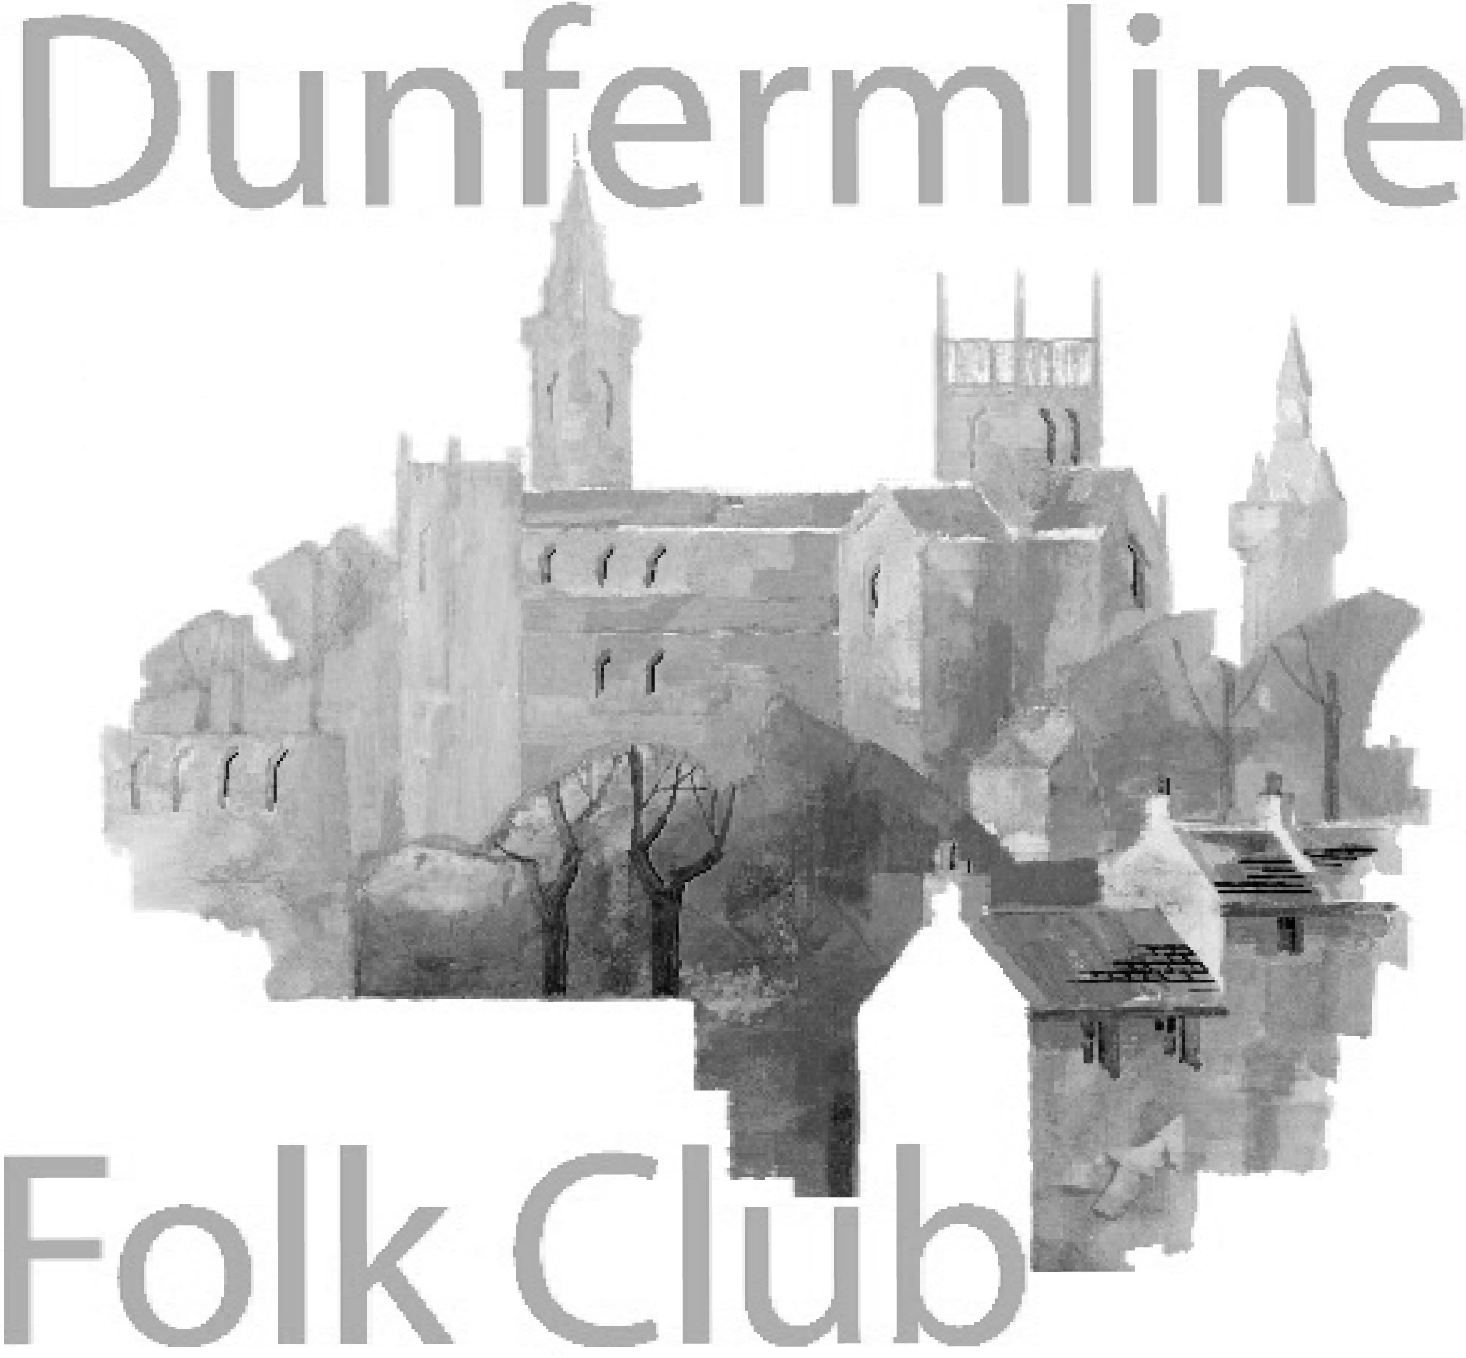
Dunfermline Folk Club Events
In The Glen Tavern, 110-112 Pittencrieff St, Dunfermline KY12 8AN

8.00pm start every Wednesday

July 2019
3 Ivan Drever Orcadian musician whose lyric song-writing, extensive traditional repertoire and virtuoso guitar playing have been part of the Scottish music scene for over 30 years. see www.ivandrever.co.uk. Club singer: Robin McLean. Entry £8 (£6 for members)​​​​
10 Peter and Barbara Snape The Snapes are two fine performers with a well-deserved national reputation for performing traditional British folk music.
With carefully researched material from their native North West of England, they will leave you in good spirits. Their selection of traditional songs with melodeon accompaniment is infectious and compels you to listen and take part. see http://www.thesnapes.org.uk/ Club Singer: Ena Robertson. Entry £8 (£6 for members)​​
17 Ella Munro Ella Munro is a young folk singer from the Isle of Skye, currently based in Glasgow. In 2017 she became a BBC Radio Scotland Young Traditional Musician of the Year finalist and has toured Scotland and beyond successfully since, however, with a passion for some of the most well-loved Scottish folk songs, she has discovered that folk clubs are where she would most like to sing. With a much-awaited debut EP on the way and sell out performances behind her, she is sure to have everyone singing along! See her on youtube Club singer: Alex Black. Entry £8 (£6 for members)​​​
24 Tom Lewis. "It's not all about sea-shanties.... my stage presentation encompasses the tradition, my own songs (some of which I'd wager you'll have heard), songs stolen from other writers; all knitted together with engaging and informative chat. With enough choruses to keep audiences involved, about half of the show is unaccompanied; whilst the rest of the songs are underpinned with a bit of melodeon or ukulele accompaniment." Club singer: Jim Wardell. Entry £8 (£6 for members)​​
31 Session. Sing a song, play a tune, tell us a story or listen and celebrate in style.Theme: colours. Collection for the club..
August 2019
7 Brack'n'File Guitarist Tony Mitchell, Shetland based bassist Rick Nickerson and singer Maureen Brack - The group performs traditional and contemporary songs and instrumentals. See https://www.facebook.com/BracknFile/ Club singer: Jeanie Gardner Entry £8 (£6 for members)​
14 Claude Bourbon - medieval & Spanish blues ​ www.claudebourbon.org/​ Club singer: Luci McLeman. Entry £8 (£6 for members)​
21 Ewan Macintyre Band . Puppeteer, musician and ex-lead singer songwriter of the award-winning Edinburgh collective Southern Tenant Folk Union. Ewan Macintyre has a rare ability to pen songs in a range of styles. Together with his band from Canada and Scotland, Ewan Macintyre weaves his own blend of folk pop traditions. see http://www.ewan-macintyre.org Club singer: Belle Hammond. Entry £8 (£6 for members)​
28 Session. Sing a song, play a tune, tell us a story or listen and celebrate in style. Collection for the club.
September 2019
4 Jim Jack and John Graham John plays a number of instruments including Fiddle, Mandolin and Guitar while Jim is on Guitar. They both share the vocal duties. Their act evokes much of the spirit of the folk revival with ample opportunities to join in choruses and a fair smattering of humour. See https://www.facebook.com/folkandfiddle/ Entry £8 (£6 for members)​
11 John Ward Trio. Born from John’s experience of life in a tough and gritty East Anglian fishing port along with boat builder Les Woodley they together bring performances that are home-spun and from the heart. Add in harmonies from Scots girl, Lynne, who hails from Clydeside, and the sound is complete. With 3-part harmonies, John's songs and traditional repertoire, accompanied by guitar, double bass, mandolin, accordion, harmonica, whistles and bodhran, and relaxed banter and humour. see http://www.johnward.org.uk/ Entry £8 (£6 for members)​​
18 Pernille and Stephen Quigg. The Scottish/Danish duo of Stephen and Pernille Quigg. Stephen Quigg is a well-established folksinger who has made a living playing music for over 40 years. The combination of the two voices in close harmony in songs whether traditional or contemporary interspersed with anecdotes and a touch of humour has received much praise from both audiences and organisers. A concert with The Quiggs is a chance to hear folksong in its original form - simple, yet highly expressive, beautiful harmonies and songs that seek the audience's participation. http://www.stephenquigg.com/ Entry £8 (£6 for members)​
25 Session. Sing a song, play a tune, tell us a story or listen and celebrate in style. Collection for the club..

Please note that the programme may change due to circumstances outwith our control - especially for events several months in the future. Please check again before coming to the club.

For further information visit www.dunfermlinefolkclub.co.uk or our Facebook page

